In this lesson we are going to continue learning different ways of manipulating elements once we select them. We have already talked about manipulating styles, changing classes, removing classes, we have talked about altering the *textContent* and *innerHTML.*

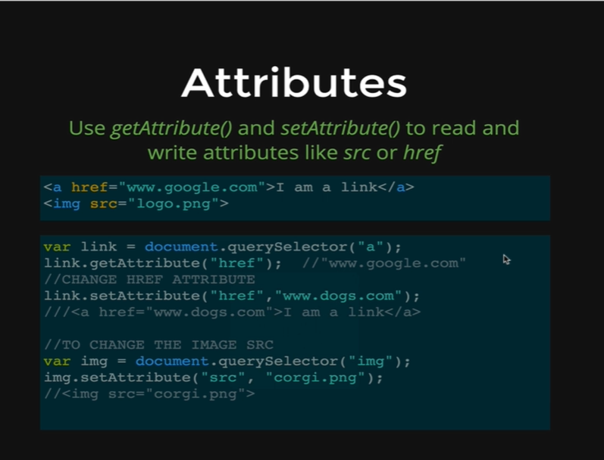

Now, we are going to talk about Manipulating Attributes. Attributes are things like,

*href= “www.google.com” or src= “logo.png”*

They always follow the syntax of being declared in opening tags with a property equal to a link,

*<a href= “www.google.com”>*

*<img src= “logo.png”>*

Attributes are important and sometimes we want to manipulate them, we want to change things. We are going to do some simple things early on like changing links on Google’s homepage to be bing.com. Changing attributes is something important and useful in real projects.

If we make an image slider for instance, a lot of times image galleries and image sliders are made by changing the source (src) of an image and its just one image and the source is being changed.

Its just one quick example but we are going to talk about, how we can retrieve the value of specific attributes and how we can also alter or manipulate the value.

On the picture above we have an anchor tag,

*href= “www.google.com”*

and an image tag with,

*src= “logo.png”*

We select the anchor tag to start and save to *link* variable,

*var link = document.querySelector(“a”);*

and there is a method that we can use called *getAtribute,*

*link.getAttribute(“href”);*

*getAttribute* retrieves the specific value that we asked for. Here, we are asking for the value of *href* attribute and it is going to return us,

[*www.google.com*](http://www.google.com)

and we can change that attribute using the *setAttribute* method.

*link.setAttribute(“href”, “www.dogs.com”);*

the s*etAttribute* takes two arguments, the first one is the name of the attribute, and the second one is the value that we want that attribute to change to.

In this case, we are changing the *href* to be [www.dogs.com](http://www.dogs.com).

Now, we will demonstrate these methods on our HTML page that we were using previously.

*<!DOCTYPE html>*

*<html>*

*<head>*

*<title>DOM Demo</title>*

*<style type = “text/css”>*

*.big {*

*font-size: 100px;*

*color: orange;*

*border: 5px solid red*

*}*

*</style>*

*</head>*

*<body>*

*<h1>Welcome to My DOM</h1>*

*<p>Corgi mixes are <strong>super</strong> adorable</p>*

*<ul>*

*<li>Orchids</li>*

*<li>Succulents</li>*

*<li>Tulips</li>*

*</ul>*

*<img src=* [*http://barrelhorseworld.com/dogs/images/1145556d.jpg*](http://barrelhorseworld.com/dogs/images/1145556d.jpg)*>*

*<img src=* [*http://api.ning.com/files/8Ni7RKwUY0n21uCgBw2JAxhPqmlBSklPmAiXbElaMFfa30mZFQKiE5gcWZP2iZJlSLIrtvQ3j4UH3Ezo5ZIc84ovRRC2J2ZT/TobySnow20.jpg*](http://api.ning.com/files/8Ni7RKwUY0n21uCgBw2JAxhPqmlBSklPmAiXbElaMFfa30mZFQKiE5gcWZP2iZJlSLIrtvQ3j4UH3Ezo5ZIc84ovRRC2J2ZT/TobySnow20.jpg)*>*

*</body>*

*</html>*

*Output:*

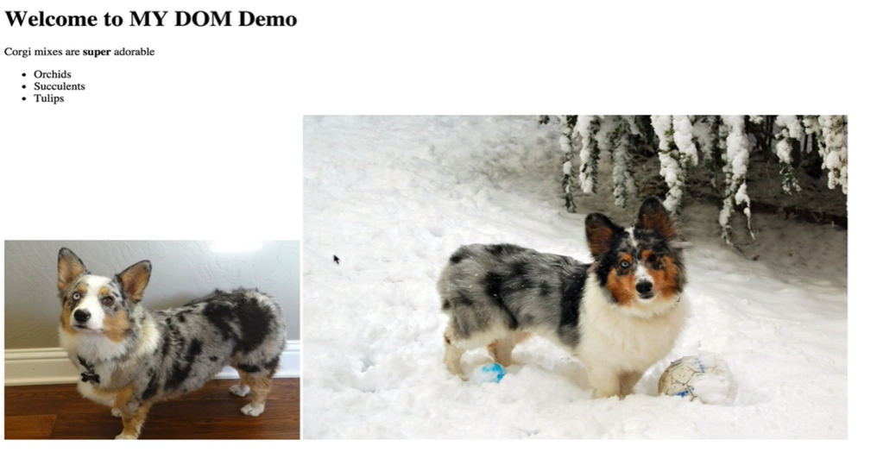

We are going to use *getAttribute* to retrieve the source of the first image on our page.

*Console coding:*

*var img1 = document.getElementsByTagName(“img”)[0]*

*img1*

* *<img src= “http://barrelhouseworld.com/dogs/images/1145556d.jpg”>*

*img1.getAttribute(“src”);*

* *“http://barrelhouseworld.com/dogs/images/1145556d.jpg”*

We got our source using the *getAttribute* method on the *img1* variable.

If we want to change this image then we have an image of another dog, that we will use in the s*etAttribute* method, where we pass the link as our second argument.

*img1.setAttribute(“src”, “http://api.ning.com/files/EYtQDtv99qF7p2BorWZXnUq2kuBRNn0sSD3zhfSB35FZyZrqTd0cxUaGGXM*vh*iMZ4mPHKo8ibQnXV*uxLkiNgRmFerTy01/corgi_husky_mix_hybrid_breed.jpg”);*

After we hit *Enter* on our console, we get the new image updated on our website.

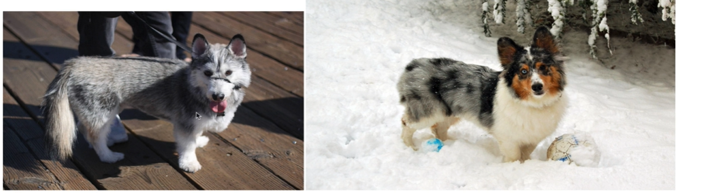

We can do the same thing to the second image; we just need to select it.

*Console coding:*

*var img2 = document.getElementsByTagName(“img”)[1]*

*img2.setAttribute(“src”, “http://api.ning.com/files/EYtQDtv99qF7p2BorWZXnUq2kuBRNn0sSD3zhfSB35FZyZrqTd0cxUaGGXM*vh*iMZ4mPHKo8ibQnXV*uxLkiNgRmFerTy01/corgi_husky_mix_hybrid_breed.jpg”);*

*Output:*

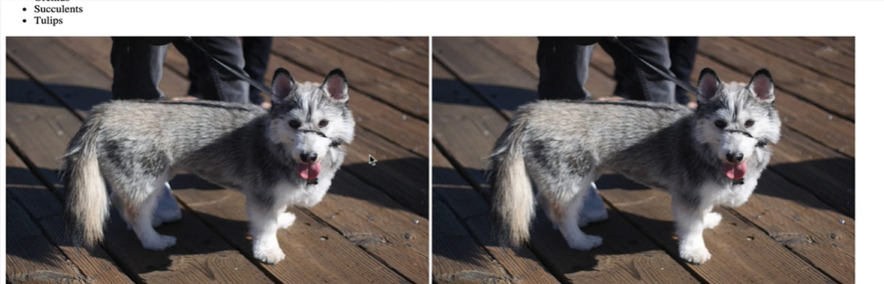

Now we have two of the adorable huskies on our website.

Just for variety we will add an anchor tag on our HTML page.

*<!DOCTYPE html>*

*<html>*

*<head>*

*<title>DOM Demo</title>*

*<style type = “text/css”>*

*.big {*

*font-size: 100px;*

*color: orange;*

*border: 5px solid red*

*}*

*</style>*

*</head>*

*<body>*

*<h1>Welcome to My DOM</h1>*

*<p>Corgi mixes are <strong>super</strong> adorable</p>*

***<a href= “www.google.com”>LINK TO GOOGLE</a>***

*<ul>*

*<li>Orchids</li>*

*<li>Succulents</li>*

*<li>Tulips</li>*

*</ul>*

*<img src=* [*http://barrelhorseworld.com/dogs/images/1145556d.jpg*](http://barrelhorseworld.com/dogs/images/1145556d.jpg)*>*

*<img src=* [*http://api.ning.com/files/8Ni7RKwUY0n21uCgBw2JAxhPqmlBSklPmAiXbElaMFfa30mZFQKiE5gcWZP2iZJlSLIrtvQ3j4UH3Ezo5ZIc84ovRRC2J2ZT/TobySnow20.jpg*](http://api.ning.com/files/8Ni7RKwUY0n21uCgBw2JAxhPqmlBSklPmAiXbElaMFfa30mZFQKiE5gcWZP2iZJlSLIrtvQ3j4UH3Ezo5ZIc84ovRRC2J2ZT/TobySnow20.jpg)*>*

*</body>*

*</html>*

*Output:*

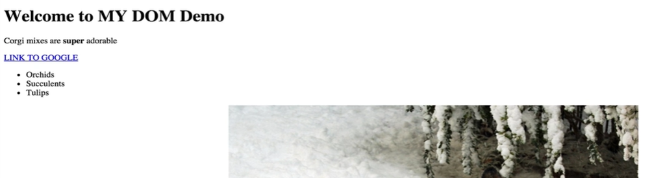

And we can change the link using the methods that takes us to Google, and it will now take us to corgis.com on clicking the link.

*Console coding:*

*var a = document.querySelector(“a”);*

*a.setAttribute(“href”, “http://www.corgis.com”);*

*a*

* *<a href= “www.corgis.com”>LINK TO GOOGLE</a>*

*Output:*

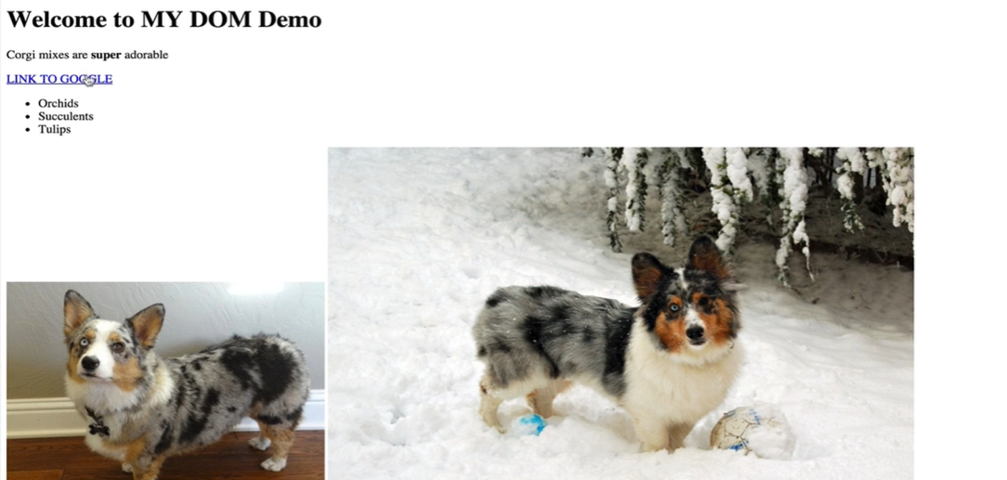

On clicking the link, we get migrated to the page below,

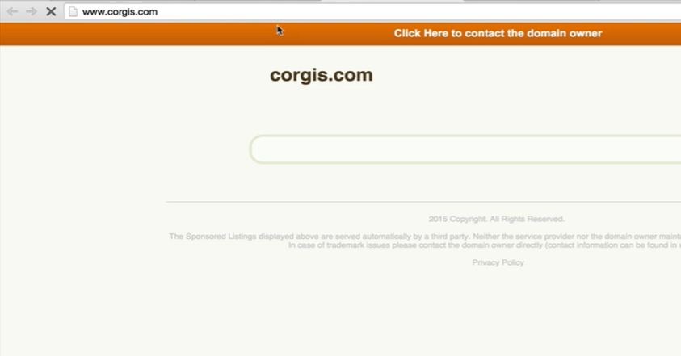

The last thing is we need to update the link so that it does not say *LINK TO GOOGLE.*

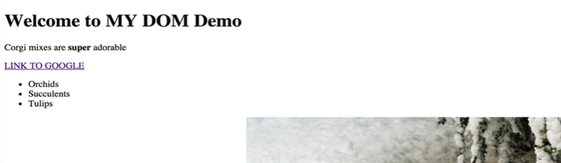

*Console coding:*

*a.textContent = “LINK TO CORGI.COM”*

* *“LINK TO CORGI.COM”*

*a*

* *<a href= “http://www.corgi.com”>LINK TO CORGI.COM</a>*

*Output:*

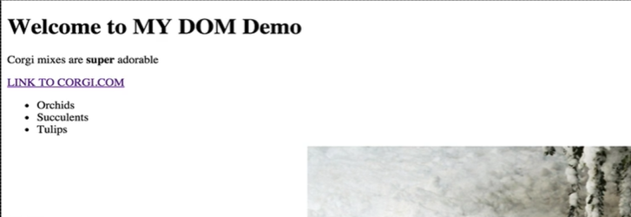

To wrap up, we have *getAttribute* and *setAttribute* and those work in any attributes. We showed it for *href* and *src,* but we can use it if we want it to change an *id,* to change a *class,* or any other attribute those are out there. There are quite a few more, but these are the more common ones that we will work with.